27. Breadth First Search (BFS)
AIM
To write a Prolog program to implement Breadth First Search (BFS) for traversing a graph.
OBJECTIVE
- To understand the concept of Breadth First Search.
- To implement BFS using Prolog.
- To traverse a graph level by level.
- To understand the use of lists and recursion in Prolog.
ALGORITHM
- Start the program.
- Define the edges of the graph using facts.
- Represent the graph as connected nodes.
- Initialize the queue with the starting node.
- Remove the first node from the queue.
- Visit the node if it has not already been visited.
- Add its unvisited neighboring nodes to the end of the queue.
- Continue until the queue becomes empty.
- Display the BFS traversal order.
- Stop.

FLOWCHART
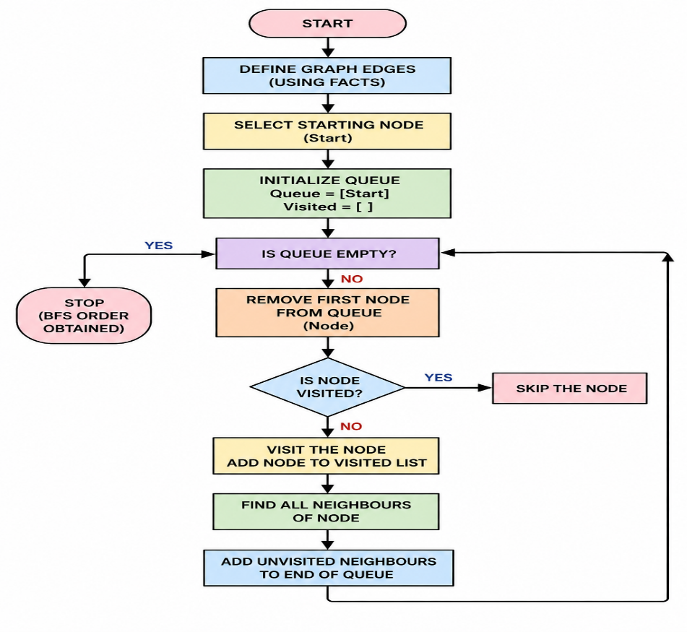
CODE:
% GRAPH EDGES
edge(a, b).
edge(a, c).
edge(b, d).
edge(b, e).
edge(c, f).
edge(c, g).
% MAKE THE GRAPH BIDIRECTIONAL
connected(X, Y) :-
edge(X, Y).
connected(X, Y) :-
edge(Y, X).
% BFS IMPLEMENTATION
bfs(Start, Order) :-
bfs_queue([Start], [], Order).
bfs_queue([], _, []).
bfs_queue([Node|Queue], Visited, Order) :-
member(Node, Visited),
bfs_queue(Queue, Visited, Order)
bfs_queue([Node|Queue], Visited, [Node|Order]) :-
\+ member(Node, Visited),
findall(Next,
(connected(Node, Next),
\+ member(Next, Visited),
\+ member(Next, Queue)),
Neighbours),
append(Queue, Neighbours, NewQueue),
bfs_queue(NewQueue, [Node|Visited], Order).
OUTPUT:
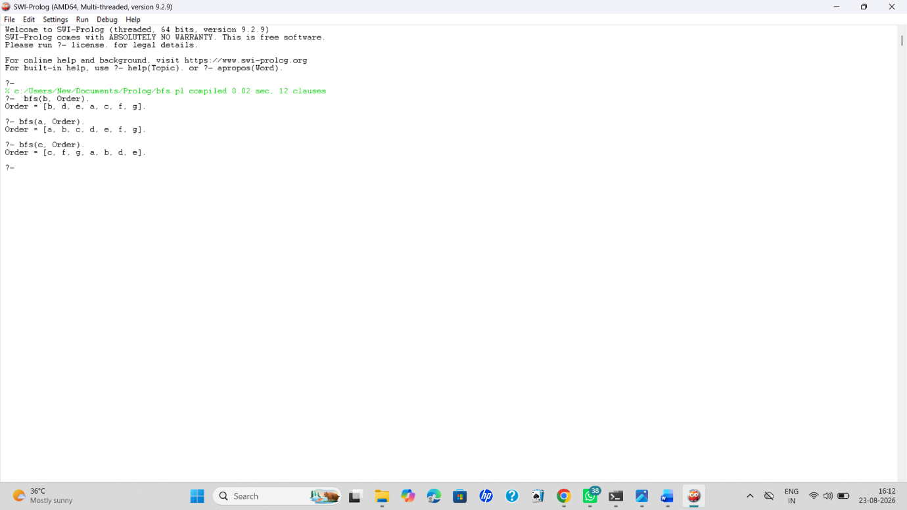
RESULT:
Thus, the Breadth First Search (BFS) algorithm was successfully implemented in Prolog. The graph was traversed level by level, starting from the specified node.

